COPY 5
( conv -> pool -> drop -> ) x 7 -> conv
Alternate pool layers true and false
Dropout Keeping Probability : 0.9
Adam Optimizer
tf.reduce_mean
Learning Rate : 1e-3

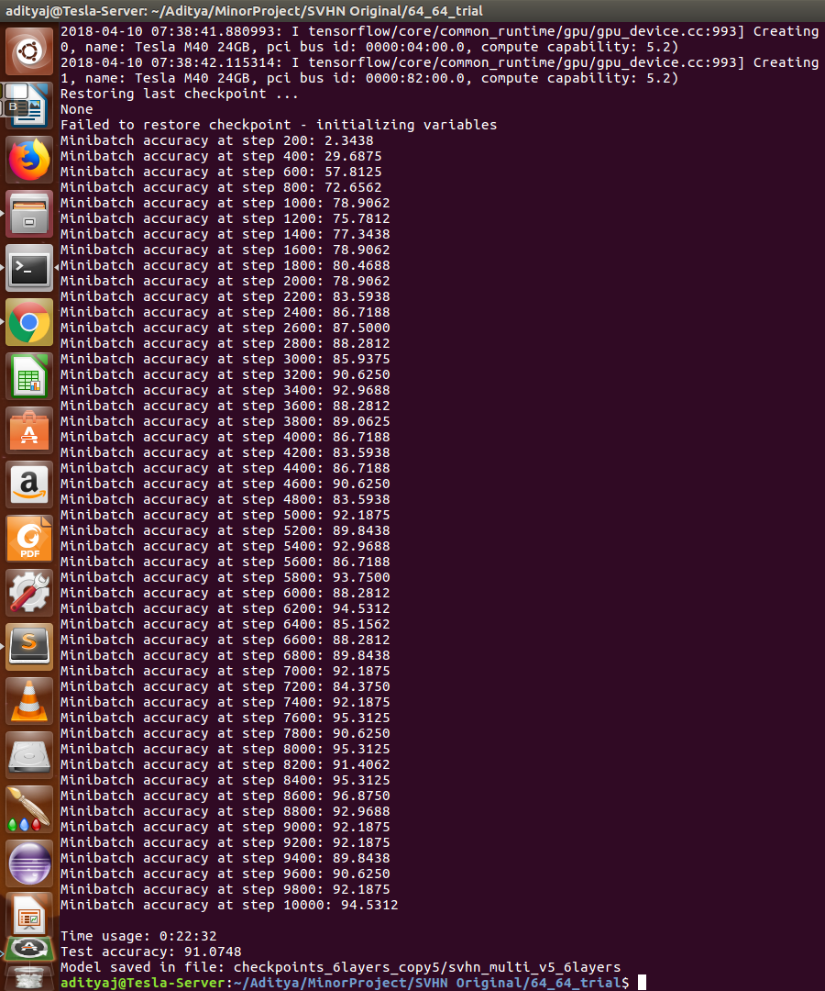

COPY6
( conv -> pool -> drop) x 7 -> conv
Alternate pool layers true and false
Dropout Keeping Probability : 0.95
Adam Optimizer
tf.reduce_mean
Learning Rate : 1e-3

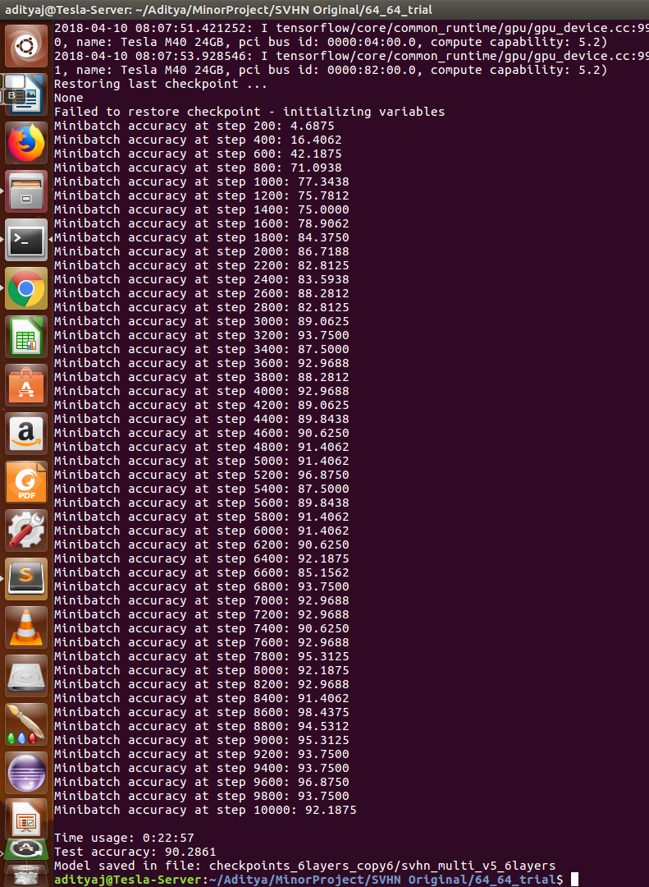

COPY9
( conv -> pool -> drop) x 7 -> conv
Alternate pool layers true and false
Dropout Keeping Probability : 0.85
Adam Optimizer
tf.reduce_sum
Learning Rate : 1e-3

COPY10
( conv -> pool -> drop) x 7 -> conv
Alternate pool layers true and false
Dropout Keeping Probability : 0.9
Adam Optimizer
tf.reduce_sum
Learning Rate : 1e-3

